GCBB NEWSLETTER VOL.1 04-22-2019

President: Brian Clifton
Welcome everyone,
WOW what an exciting Draft we just had. We plugged holes. Drafted the Best Player at each position. Got value picks, maybe reached a little. Between free agency and the draft, I think we had one of the top 5 in the league. Things are really looking up for us and for the first time since the 2002-2003 years I am VERY EXCITED for an upcoming Browns season. The episodes pf Building the Browns isn’t helping my excitement either.
So this year the Browns Bengals game is on DEC.29th. While it is in between holidays, this game has the potential to be HUGE for the Browns. This game can have playoff implications.
I have secured 72 tickets in 3 rows for us. I want us to show out and I want us to bark LOUD Bark STRONG but most of all I want us to BARK TOGETHER.
TICKETS ARE 60 Each.. 47 for the ticket 13 for the Tailgating. I’d like to keep it 60 and not break it up. There is a lot to plan for tailgating and I rather plan the lot than this will show this wont this surprises us etc. Just easier.
There is 3 ways you can pay by check, by cash or by credit card. The check is obviously by mail. Cash is Obviously by person. Credit card can be by person or by Phone. You can call me at 513-288-1347 . Keep in mind I have kids and I have a job so I will not be selling tickets at 3 AM LOL.

If you wish to pay by check send a check to 4348 St. Dominic Drive Cincinnati Ohio 45238

I can not wait for this season to start

GO BROWNS

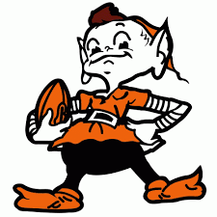 V.P. Amanda Craig

WORD FROM OUR V.P. AMANDA CRAIG…
To my GCBB Fam:
Well, the draft is over y'all. I don't know about you, but I feel pretty good about it. Compared to the past several drafts, I think we did well. Even when we drafted Baker last year, I was one of those people thinking “Oh Lord, not another flop quarterback”. Obviously, I was ecstatic when it all worked out. This year, the draft was VERY different and it was nice to not be ‘desperate’ for anyone. I feel like all of these guys are awesome additions and will bring something great to the table.
I have to be honest with you all, I’m a little worried. I love, love, LOVE my Brownies, but all this hype has made me a nervous wreck. I've watched the Browns my whole life and all I have seen for the last 29 years is disappointment. I don't know anything else; so all this hope and excitement is a little scary for me at the moment. It's not that I don't have faith in us, I have always believed this day would come, but now that it's here… I don't know what to think. I'm sure you guys know what I'm talking about. I just can't wait to see what we do because it is gonna be a huge year for us. Until next time…
Your VP,
Amanda “Little Glitter” Craig

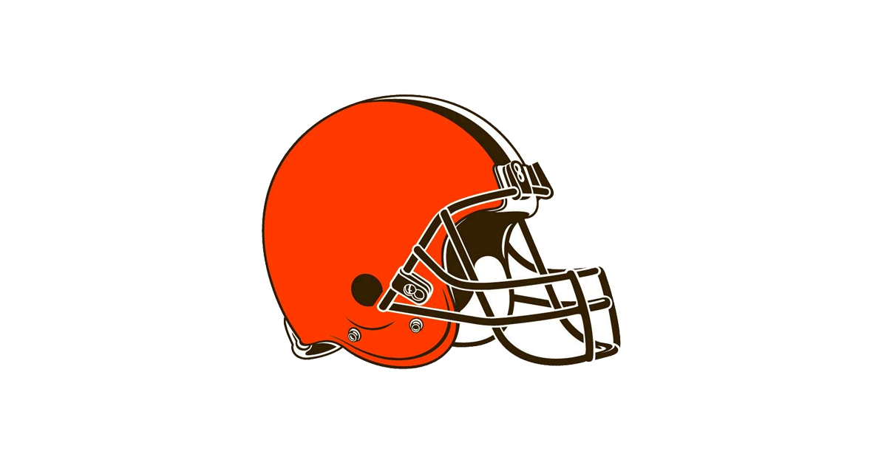 Special post-draft Report: Paul Theil
BROWNS 2019 DRAFT
Lacking a first-round choice certainly takes the luster off of a draft. But first round picking is the easiest part. The real work of the draft lies in finding a starter or two and a couple of solid rotation contributors later in the draft. It is commonly said that it takes three years to truly evaluate a draft. But this is at least misleading. How a team’s draft picks look after their first three years can be just as much a result of how well or poorly they were coached, what system they were put into and what they were asked to do as how talented they were when drafted. A draft can (and should) be rated immediately based on how good the prospects are at what are a team’s greatest needs. Prior to the draft many were claiming that the Browns had the best talent in the division if not in the conference. But while this might be true (on paper) of their offense, the 30th in the league ranking of their defense raised questions about whether their defense was even mediocre. The Browns drafting reflected this latter attitude.
In the second round the Browns traded up three spots at the cost of one of their three fifth round picks to select cornerback Greedy Williams, 6-2 185 4.37 out of Louisiana State. Of the dozens of mock drafts that I saw leading up to the draft, every single one of them had Williams as a first-round pick. Williams is long and smooth with excellent balance, body control, accelerating and speed. He has natural ball skills and is a reliable tackler. The complains about Williams are that he is technically unrefined relying too much on his natural abilities and that he is not an eager and aggressive tackler. But if he can just be an effective tackler, it will be interesting to see if he or Denzel Ward has the better career.
In the third round the Browns selected linebacker Sione Takitaki, 6-1 238 4.63 out of Brigham Young. Takitaki is long, athletic, strong and sudden but unrefined. He was kicked off the team as an underclassman but came back to be named a team captain. He could end up eventually starting at any of the 4-3 linebacker positions.
In the fourth round the Browns selected defensive back Sheldrick Redwine, 6-0 196 4.44 out of Miami, Florida. Redwine is well-built, agile and aware and shows agility, quickness and speed. There is some question whether he fits as a free safety, a strong safety or a slot cover back, but this is the kind of versatility that most NFL teams are now looking for.
With their first fifth round pick the Browns selected linebacker Mack Wilson, 6-1 240 4.71 out of Alabama. Wilson has an ideal linebacker frame, good balance, acceleration and speed and terrific initial quickness and power. However, Wilson is technically raw being only a one-year starter. He could end up starting at any 4-3 linebacker position eventually and was rated by many, including ESPN’s Mel Kiper, as a second-round talent. Many national commentators claimed that if Wilson develops as he should, then Takitaki is a wasted pick. I disagree. Many believe that Genard Avery is more of a pass rush specialist than a three-down linebacker. Joe Schobert led the league in missed tackles, and Christian Kirksey was rated by Pro Football Focus as one of the ten worst qualifying linebackers in the NFL. If anything, the Browns might still be looking to draft a linebacker early in the 2020 draft.
With their second fifth round pick the Browns selected kicker Austin Seibert out of Oklahoma, the highest scoring kicker in NCAA-FBS recorded history. Seibert has
remarkable leg strength and is as close to automatic as a college field goal kicker gets. Regardless of the support the Browns showed for Greg Joseph, no NFL team any longer drafts a kicker without expecting him to win the job.
With their sixth round pick the Browns selected offensive tackle Drew Forbes, 6-5 305 5.03 out of Southeast Missouri State. Forbes is a quick, athletic mauler who dominated small-school competition but whose short arms project him to guard. Forbes is the kind of high-ceiling developmental prospect who many (including me) prefer in the late rounds.
With their seventh round pick the Browns selected cornerback Donnie Lewis, 6-0 195 4.56 out of Tulane. Lewis is a pesky cover guy and a consistent tackler who has played cornerback, safety and nickelback but is raw and thin. Lewis would have been drafted earlier if not for a broken foot that interfered with his pre-draft workouts. Lewis has some talent to develop, which is what teams look for in the seventh round.
All-in-all the Browns went into the draft without any glaring needs and came away with a starting cornerback and kicker and two linebackers and a safety who could eventually start – a good three days’ work as the push for the playoffs continues.

SCHEDULES AND UPCOMING EVENTS:
So here are my predictions on the season... what are yours?
TENN(W) SAN FRAN (W) BUFF(W) CINCY(W)
JETS(W) SEATTLE (L) PITTS(W) ARIZ(W)
RAMS(L) BYE N.E. (L) MIA(W) BALT(L)
BALT (W) DEN (W) PITTS(L) CINCY(W)

GO BROWNS… WE BARK TOGETHER!!!!!

