GCBB NEWSLETTER VOL.1 04-22-2019

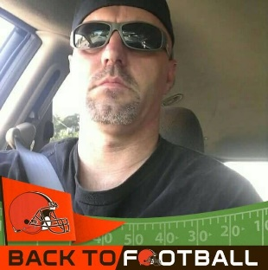 President: Brian Clifton

WOOF WOOF WOOF YOU ALL.

What an overall busy time I have been having for you members as the season approaches fast.
I got the amazing opportunity to visit the Browns during Presidents day weekend and I tell you that was a fantastic. We started the day by meeting up with other Browns Backers presidents from all over. We had presidents from Hawaii and some from overseas join us. All in all, they said this was the LARGEST turn out for browns backers. So, we all met up Friday morning and met in front of the training facility and got our packets to enter and tickets with parking for the Orange and Brown Scrimmage. We were ushered into the training camp and had a section clocked off for us only. Got to say hi to Kurt Warner, Phil Dawson was there but never coming over to us, instead talking to our kickers the whole practice. Then None other than Brad paisley the country singer from the Nationwide commercials came to visit us. He stood 3 feet from me but wouldn’t sign autographs except for a 9-year-old boy. Then out of the Blue here come BERNIE KOSAR. I ask him to sign the Jacket I got that we are raffling off. He happily said yes and signed it. I planned to load that jacket with as many autographs as I could. Christian Kirksey came over and signed one of the club shirts. The Greg Joseph came over and signed the club shirt. Megan who runs the Browns Backers Worldwide, came over to ask if we were having fun to which I joked, I got Bernie’s I just need Bakers please. She gave me a are you kidding me look and walked off, thought nothing of it and was not going to happen. Then 5 minutes later here she comes with Baker making a B-line straight to me and the Jacket. BAKER FREAKING MAYFEILD signed the JACKET, and allowed me to video himself saying Hi to my girlfriend Melissa. After that all the Browns backer’s president said in unison. LOCK UP THE JACKET and don’t let anyone else sign it. You have a One of a kind Jacket that will never be offered again.
I actually had someone up there offer me $200 for it and I turned it down. Instead we are going to raffle it off to our members. So we will be selling it for our members at $10 a raffle ticket. I am only selling 100 tickets for this Jacket. The money raised will offset the rising prices for the year, Namely Direct TV We have to help pay for and other expenses. Once 100 tickets are sold, we will Pull the name out at the Club Party. YOU DO NOT NEED TO BE PRESENT TO WIN; However WHY WOULD YOU NOT WANT TO BE. I now some people might be upset, but this was an idea brought to me from one of the Browns Presidents and echoed by many.

That night we went to Cleveland Browns stadium ( I refuse to call it the other name)
I AM EXCITED. WE BARK TOGETHER
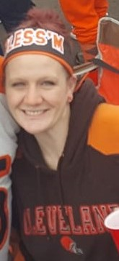
WORD FROM OUR V.P. AMANDA CRAIG…
Well guys, I finally got Glitter Bob back up to Cleveland for training camp this summer. He hasn’t been up in a couple of years and, well, who can blame him. Up until half way through last season, the city was just a reminder of the giant disappointment that was the Cleveland Browns. That time is over now. Cleveland is an awesome city, it’s about time we have an awesome team to go with it. They aren’t the best but I did get a few good photos to share with you guys from camp. And a few other extracurricular photos you might enjoy. On a side note; my mom (Glitter Bob’s daughter), Pam, had open heart surgery that did not go so well and is really having a hard time. She is improving, but the road to recovery will be a very long and difficult one. If you could send some good vibes and keep her in your thoughts, we would greatly appreciate -Your VP, Amanda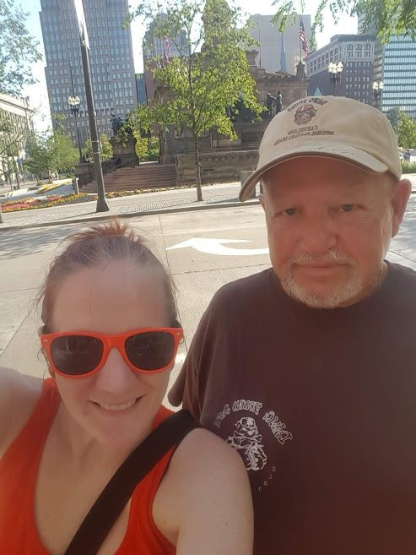 Roaming around Cleveland 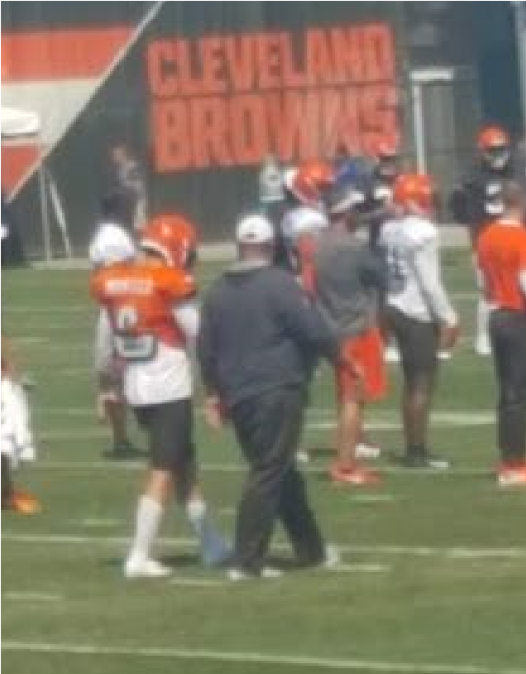Freddie and Baker, 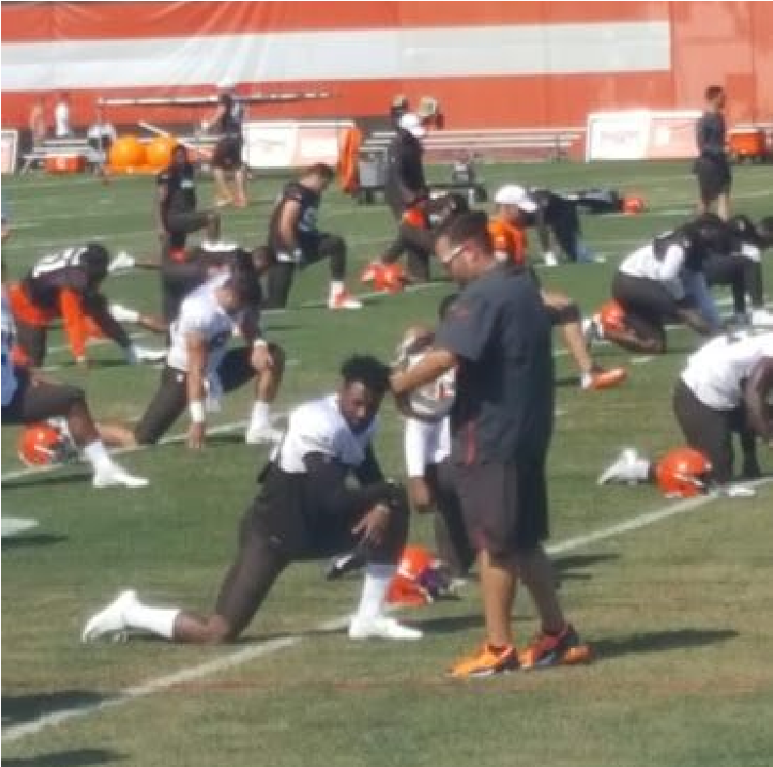 JUUUUIIIICCCCCEEEE 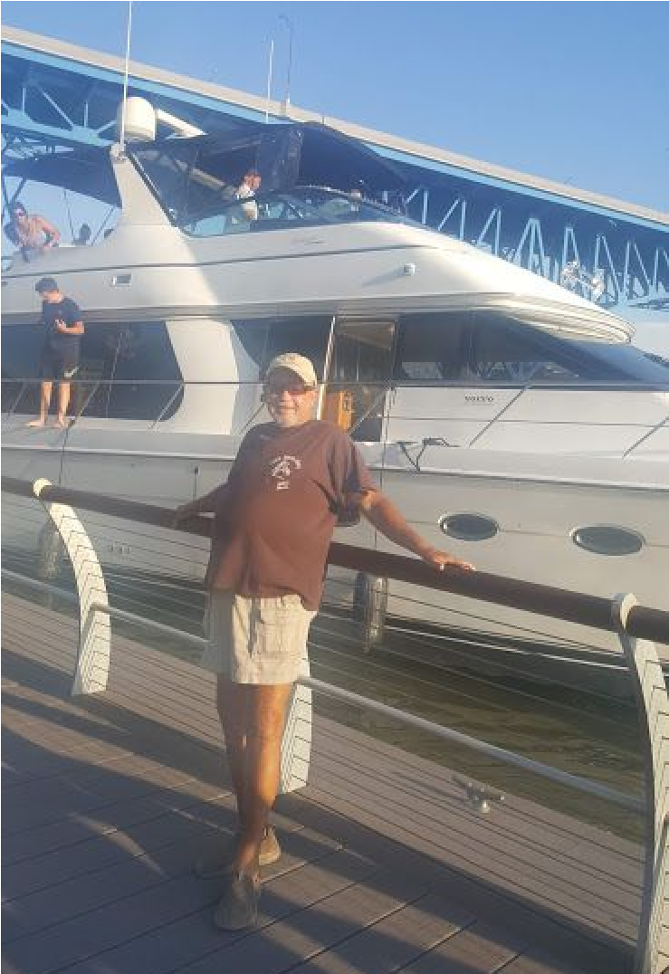Glitter Bob’s nee yacht.
A Legacy Article from Chris Allen:
I have been a Browns Fan as long as I remember, though I never have lived anywhere close to Cleveland. I inherited the Browns passion from my father Bill who grew up in Sharon, PA, in a divided family. My father and my grandmother were Browns Fans, my grandfather and aunt were, well, they were Steelers fans. My father would tell of stories of the greats of his childhood like Graham, Lavelli and playing in high school against Paul Warfield. I was hooked.
My alliance with the GCBB started in college in the late-80’s when a good friend, Mike McCarty took me down to Tickets in Covington to catch a game. Yes, Paul was there with his stack of Brown’s News Illustrated’s and his flashlight. From that time, the club it seemed, moved “Homes” seemingly more often than the Browns have changed coaches, GM’s, and quarterbacks. Slatt’s has been a wonderful host.
As Glitter Bob noted, Joey, Bob, Mike and I revived the GCBB in 1998, a year before they came back onto the field. Mike was later transferred to Puerto Rico. Joey brought in a friend from work to take over as Treasurer since she was in accounting. Most of you know, and love her, as Ann. Over the past two decades, I was involved behind the scenes more often than not. If you have read a newsletter between 1998 and 2017, you have seen my work. I wrote my own articles, and a couple of times, I wrote everyone’s articles. I wore many hats and carried several personalities you could say.
I have so many great GCBB memories that it is hard single out my favorites. The first is as Bob noted, was the Club Trip to New Orleans, on Halloween, to watch Tim Couch’s Hail Mary pass to Kevin Johnson to secure our win. The second, was the Reunion Weekend we held the weekend that the Bungles opened Paul Brown Stadium. The club purchased I think 800 tickets for the game, we had a huge tailgate party that many out-of-towners talk about, and we had a celebration at Willies in Covington that featured Browns greats, Greg Pruitt, Hanford Dixon, and Doug Dieken. What an amazing weekend.
Since then, our Browns have taken on more twists and turns than the Banshee ride at Kings Island. And as Baker has now taken the reigns of this new Browns club, I am thankful to Brian and Lil Glitter for taking the reins of the GCBB. Great things are on the horizon, and I look forward to be sitting next to Bob at that Super Bowl.
Just remember, life is tough, BARK HARD!!!

THINGS THAT ARE HAPPENING
Sept 8th Browns BEAT the Titans Club Raffle 50/50 Split
Sept 16th MONDAY NIGHT JETS 50/50 split
Sept 22nd RAMS UPSET SPECIAL 50/50 split
SEPT 29th CLUB PARTY RAVENS RAFFLE AND 50/50split

OK after talking with Clint at Slatts I told him I wanted a more exclusive menu for us members he agreed and we agreed on this menu I hope you all enjoy it
Browns Menu
Drinks:
$2.00 Mil light Draft Refill
$3.5 Tall Mil light (no cup)
$4 House Bourbon
$5 House Bloody Mary
$4 House Vodka
$4 Mimosa
$5 BeerMosa
$5 Beer w/ tomato juice
$5 *SHAKE AND BAKE SHOT (Mind eraser)
Food:
Appetizers:
$7 for 6 $11 for 12 Raven Skeletons (garlic parm, hot, mild, bbq)
$7 Bloody Bengal Nachos (buffalo nacho)
$6 Steelers on a platter (Smothered Chips with carnitas or chicken, olives, lettuce and cheese sauce)
$7 Roll-ing over the NFC (Spring Rolls)
$7 Fried Bengal Stripes (zucchini)
$6 ‘Berea’ cheese and pretzels
Soup:
$4.00 Dawg Chili with cheese and onion
Salad:
$10 TacOdell Salad
$10 Seasonal Salad
Lunch Items served with chips or fries
$7 ¼ pound CheeseBaker with American Cheese
$10 Double CheeseBaker with American Cheese
$7 BBQ Corbett Sandwich
$7 (4) Kirksey tenders w/honey mustard
$6 Grilled Tretter-Cheese
Dessert:
$4 Dog Pound Cake with Ice Cream

GO BROWNS… WE BARK TOGETHER!!!!!

